**Requirements:**



**Set of Use Cases:**

|  |  |
| --- | --- |
| # | Use Case |
| UC 1 | Login to the housing application |
| UC 2 | View on campus Housing details |
| UC 2.1 | View apartment/residence hall floor plans |
| UC 2.2 | View apartment/residence hall images |
| UC 2.3 | View apartment/residence hall reviews |
| UC 2.4 | Provide apartment/residence hall feedback |
| UC 2.5 | Compare apartment/residence hall |
| UC 3 | Check application status |
| UC 4 | Apply to on-campus housing |
| UC 4.1 | Select apartment/residence hall |
| UC 4.2 | Enter Personal Details |
| UC 4.3 | Submit application |

UTA Housing App



Student

<<include>>

<<include>>

<<include>>

<<include>>

<<include>>

<<include>>

<<include>>

<<include>>

**Use Case Traceability Matrix:**

|  |  |  |  |  |  |
| --- | --- | --- | --- | --- | --- |
|  | Priority Weight | UC1 | UC 2 | UC 3 | UC 4 |
| R1 | 20 | X |  |  |  |
| R2 | 20 |  |  |  | X |
| R3 | 15 |  |  | X |  |
| R4 | 4 |  | X |  |  |
| R5 | 2 |  | X |  |  |
| R6 | 3 |  | X |  |  |
| R7 | 2 |  | X |  |  |
| R8 | 3 |  | X |  |  |
| R9 | 3 |  | X |  |  |
| R10 | 2 |  | X |  |  |
| Score | | 20 | 19 | 15 | 20 |

**Increment Matrix:**

|  |  |  |  |  |  |  |
| --- | --- | --- | --- | --- | --- | --- |
| Use Case | Priority | Effort (person-weeks) | Depends On | Iteration 1 (due date) | Iteration 2 (due date) | Iteration 3 (due date) |
| UC1 | 20 | 1 | - | 03/17/2015 | 04/07/2015 | 05/05/2015 |
| UC2 | 19 | 3 | UC 1 | 03/17/2015 | 04/07/2015 | 05/05/2015 |
| UC3 | 15 | 2 | UC1,UC4 | 03/17/2015 | 04/07/2015 | 05/05/2015 |
| UC4 | 20 | 4 | UC1 | 03/17/2015 | 04/07/2015 | 05/05/2015 |

**Expanded Use Cases:**

|  |  |
| --- | --- |
| UC1: Login to the housing application |  |
| Actor: Student | System: UTA Housing App |
|  | (0) The system shows Sign In page. |
| (1)TUCBW the student entering his MyMav credentials, and clicking on Sign In button. | (2)The system shows the student homepage. |
| (3) TUCEW student getting signed in. |  |
|  |  |

|  |  |
| --- | --- |
| UC2: View on campus Housing details |  |
| Actor: Student | System: UTA Housing App |
|  | (0)The system displays Home page. |
| (1)TUCBW the student clicking on ‘View apartment/housing’ menu from the navigation drawer. | (2)The system shows list of oncampus housing apartment/ residence halls. |
| (3)User clicks on one of the apartment/residence halls from the dropdown menu. | (4)The system displays apartment/residence hall details including pictures, floor plan, review etc. |
| (5)TUCEW student viewing the apartment/residence halls details. |  |

|  |  |
| --- | --- |
| UC 3: Check application status |  |
| Actor: Student | System: UTA Housing App |
|  | (0)The system displays Home page. |
| (1)TUCBW the student clicks on application status button. | (2)System shows list of successfully submitted applications. |
| (3)The student selects application. | (4)System shows application status i.e. waiting list. |
| (5)TUCEW student sees application status. |  |

|  |  |
| --- | --- |
| UC4: Apply to on campus housing |  |
| Actor: Student | System: UTA Housing App |
|  | (0)The system displays Home page. |
| (1)TUCBW the student clicking on apply button. | (2)The system shows housing application form. |
| (3)Student fills the housing application form. | (4)The system validates the fields and displays application confirmation message. |
| TUCEW student sees the housing application confirmation message. |  |

**Use Case Snapshots**:

|  |  |
| --- | --- |
| **Login Success** | **Login Failure** |
|  |  |

|  |  |
| --- | --- |
| **UTA Housing Home** | **Navigation Menu** |
|  | 3 |

|  |
| --- |
| **Apartment/Residence Halls Listing** |
| 4 |

**Domain Model Diagram:**

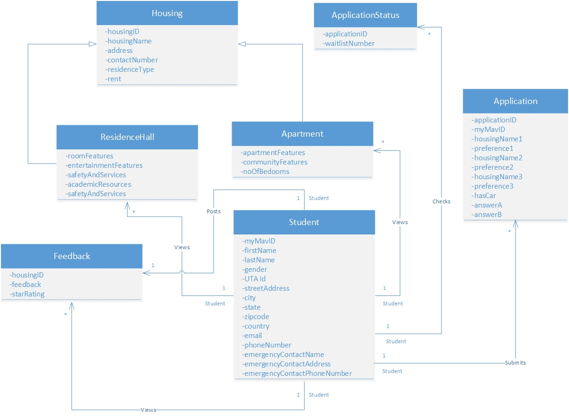

**Sequence Diagrams:**

Sign-In Sequence Diagram:

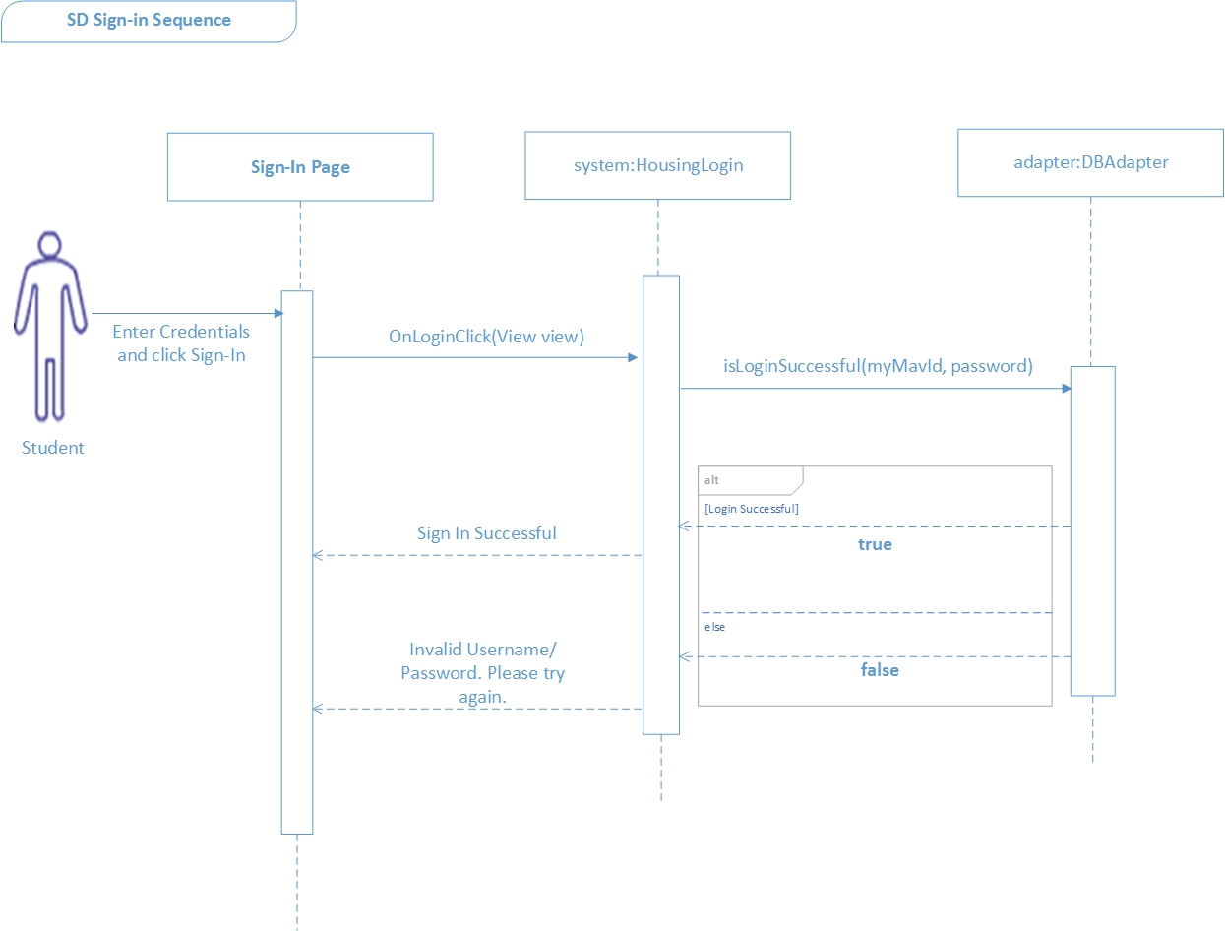

**Design Class Diagram:**

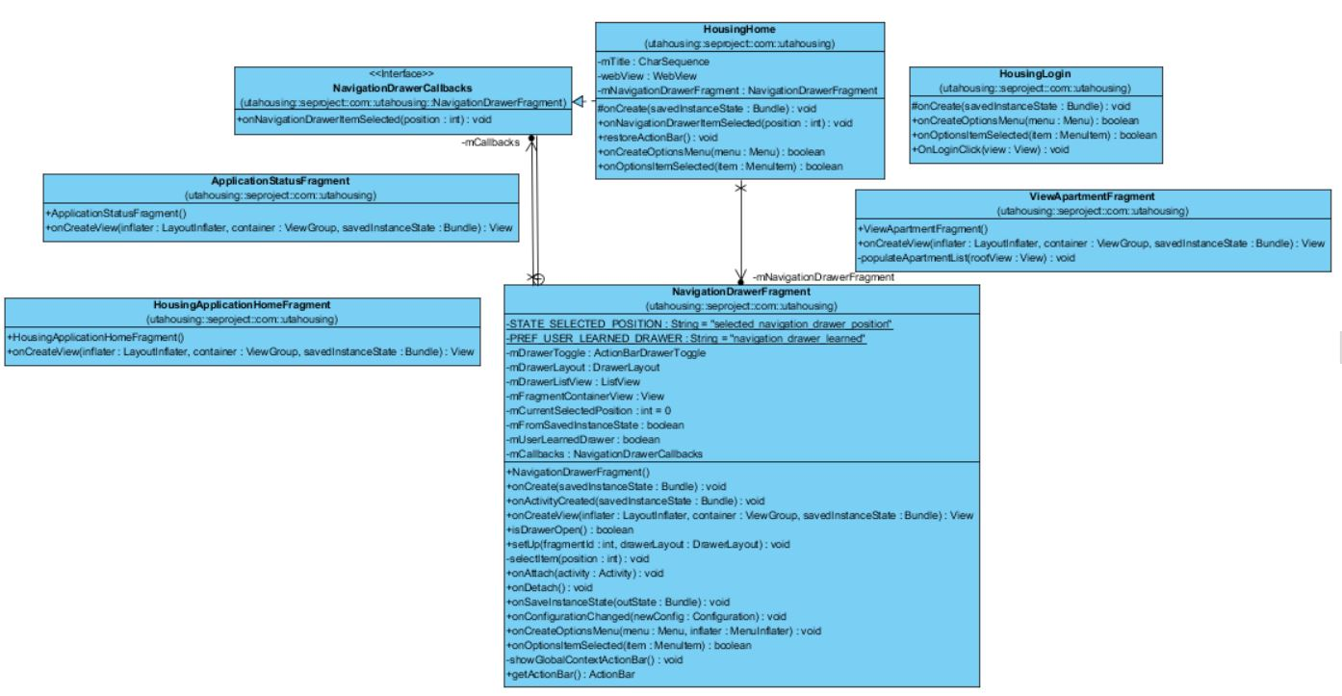

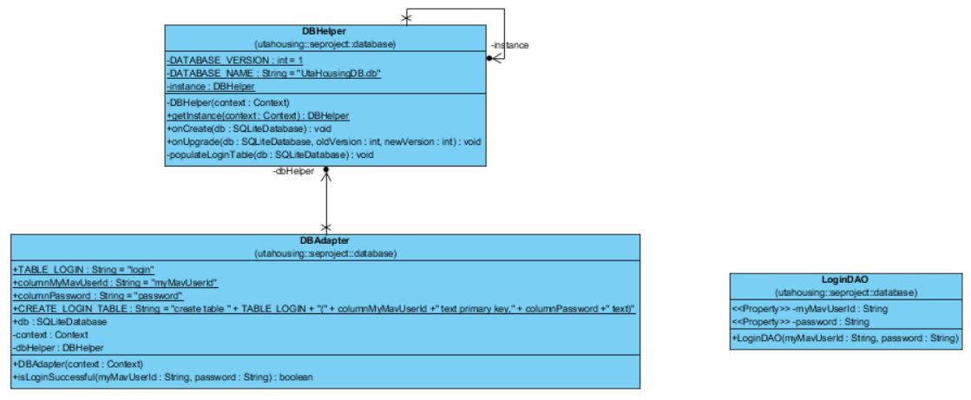

**Activity Diagram:**

**State Diagram:**

View Housing/ -

Click on View On-campus housing/ On-campus housing page displayed

Fill Application/ -

Click on Apply / Application form is displayed

Click on Application status/ Application status page is displayed

Correct Credentials/Homepage success

Homepage

View On campus housing

Apply to Housing

Sign Out

Click Sign Out/Sign out

Incorrect Credentials/Sign In page

Sign In

Click Sign Out/Sign out

Click Sign Out/Sign out

Select an application/ Application status is displayed

Check Application Status

Check Application/ -

**Functional Code Snapshots:**

Database Helper Class:

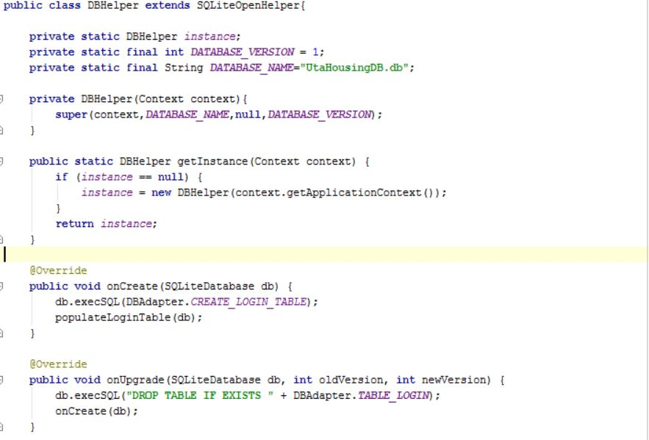

Database Adapter Class:

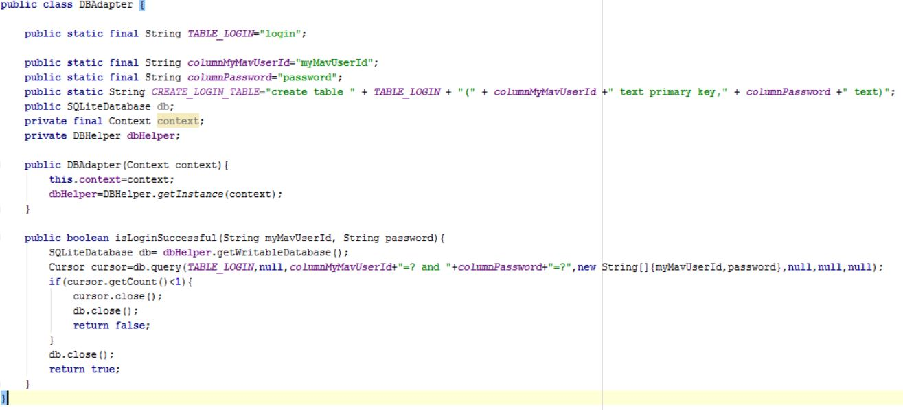

Sign-In Functionality:

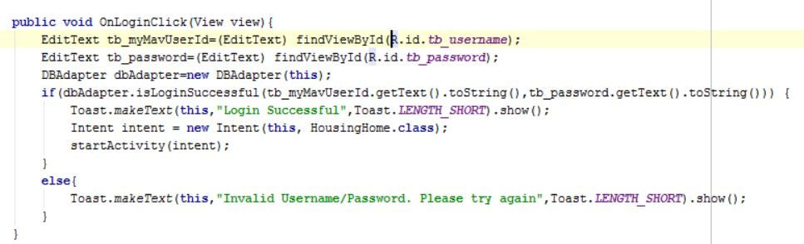

**Task Assigned:**

|  |  |  |
| --- | --- | --- |
| # | Task | Assignee |
|  |  |  |